Title Template for Extended Abstract of ATEM-iDICs '23
(for title, please center; use Arial 14)
First Author^{1*}, Second Author¹, and Other Authors ² (Times New Roman 11pt)
¹Japan Society of Mechanical Engineering, 35 Shinanomachi, Shinjuku-ku, Tokyo, Japan (Times New Roman 9pt)
² Department of Mechanical Engineering, Kikai University, 35 Shinanomachi, Shinjuku-ku, Tokyo, Japan
*Corresponding author’s email: corresponding@author.com

For the rest of the text, please use Times Roman (or Times New Roman) 10.
Introduction. This document is a template for preparing your extended abstract manuscript for the Abstracts Book of ATEM-iDICs '23. It will be published as a PDF file. Please read these instructions and follow the outline of this text.
Language. All manuscripts of extended abstracts must be in English.
Length. The manuscript should be one page long. Therefore, please compose your layout using the whole A4 page.
Page layout. The text must be 170 mm wide and 250 mm high. Do not place any text outside this area and please do not change the document setting from A4. The main body of the text is in two columns except the title, authors, affiliations, addresses and e-mail address.
Section Headings. Section headings are boldface and typed as part of the succeeding paragraph (like the section heading of this paragraph).
Page Numbers. Do not print page numbers.
Tables. Tables (style: Table 1, Table 2, ...) should be presented as part of the text. The caption should be placed above the table.
Figures. Figures (style: Fig. 1, Fig. 2, ...) also should be presented as part of the text. The caption should be placed below the figure.
If authors use tables or figures from other publications, they must ask the corresponding publishers to grant them the right to publish this material in their paper.

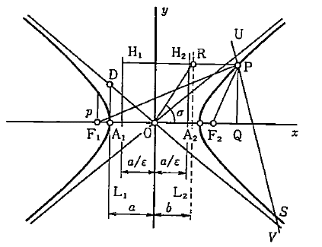
Fig. 1 Sample of a clear figure.

Equations. Equations (style: Eq. (1), Eq. (2),..) should be indented. The equations have to be numbered sequentially, and the number put in parentheses at the right-hand edge of the text as shown below:
(1)
Emphasis. Use italics for emphasizing a word or phrase. Don’t use boldface typing or capital letters except for section headings.
MSWord document styles. The extended abstract should be prepared in the electronic form as a standard document format MS Word DOCX. The extended abstract must be submitted in PDF without any security restrictions. The file size must be less than 5 MB.
References. References should be indicated in the text with superscript numbers⁽¹⁾ in parentheses. All references should be written in English, and should be given in a list at the end of the text.

- Takeuchi, Y., Trans. JSME C, 71, (2005), 1-4.
- Ahrendt, W. R. and Taplin, J. F., Automatic Feedback Control, (1984), 12, McGraw-Hill.

